Project Design Phase-II
Data Flow Diagram & User Stories
Date | 20 January 2026
Team ID | LTVIP2026TMIDS76912
Project Name | HematoVision: Advanced Blood Cell Classification Using Transfer Learning
Maximum Marks | 4 Marks

Data Flow Diagrams:
A Data Flow Diagram (DFD) is a traditional visual representation of the information flows within a system. A neat and clear DFD can depict the right amount of the system requirement graphically. It shows how data enters and leaves the system, what changes the information, and where data is stored.

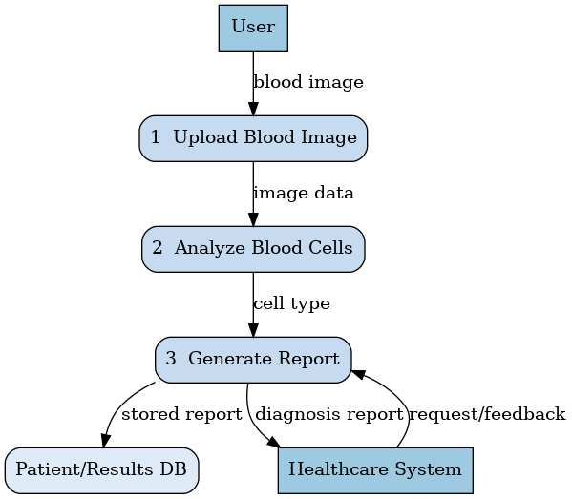

User Stories
Use the below template to list all the user stories for the product.
User Type | Functional Requirement (Epic) | User Story Number | User Story / Task | Acceptance criteria | Priority | Release
Customer (Mobile user) | Dashboard | USN-1 | As a user, I can view dashboard with upload and history options | Dashboard displays upload & results sections | High | Sprint-1
 |  | USN-2 | As a user, I can upload blood cell images for analysis | Image successfully uploaded | High | Sprint-1
  Image Upload
 | Prediction | USN-3 | As a user, I can get blood cell classification result | System shows predicted cell type | High | Sprint-1
 |  | USN-4 |  | Report displays cell type & confidence | Medium | Sprint-2
  Report Generation
  As a user, I can view analysis report after prediction
 | History | USN-5 | As a user, I can view past uploaded images & results | Previous records visible | Medium | Sprint-2
Lab Technician | Image Capture & Upload | USN-6 | As a lab technician, I can upload microscope blood images | Image stored and processed | High
  Sprint-1
Doctor / Pathologist | Diagnosis Support | USN-7 |  | Classification accuracy displayed | High
  As a doctor, I can use AI prediction to assist diagnosis
  Sprint-1

